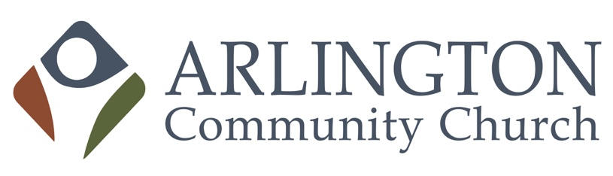
6040 Wilson Blvd
Arlington,VA 22205
703-533-9874
www.arlingtonalliance.org

FACILITY RENTAL AGREEMENT

Name: ________________________________________________________________________
Address: ______________________________________________________________________
City:__________________________________ State:__________ Zip:_____________________
Home #: ______________________ Work #: _________________ Cell #: __________________
Date of Event: ____________________ Time of Event: ___________am/pm to _______am/pm
Total Hours: ______ Rooms Needed ($150 per room/per 3 hour block)____________________
Type of Event: __________________________________________________________________
Approximate # of Guests: _____________________ (Maximum Capacity 200)
Rental $ _____________ Deposit: $____________ Additional Set-Up or Service Fees $________
Total Fees/Deposits Collected: $_______________________ Received By: _________________
Method Paid: Cash ______ Check ________ Money Order __________

Rental Conditions:
- Arlington Community Church is not liable for personal injury, loss, or damage to personal property. The renter accepts full responsibility for any such liability that may occur to them, members of their group, or any guests while on the property.
- Lease of the church property entitles the renter to use of the Worship Center for a wedding or funeral. Lease of the Worship Center includes seating for up to two hundred, use of the sound system, and piano in the Worship Center. The sound system requires an AV technician provided by the church. The technician is an additional $25 per hour (non prorated).
- In consideration for the lease of the church property for the event, the renter shall make a 50% refundable deposit of the amount stated above. In the event the renter needs to cancel, the deposit will be returned.
- Payment of the remaining rental fee balance is due, in full, seven days prior to the scheduled event. Certified personal checks, cashier’s check, or cash are acceptable modes of payment.

- Following the event, an Arlington Community Church Representative will assess the facility to determine if additional charges are required for clean-up or damage to the facility.
- The kitchen is a “warming kitchen” and not to be used for cooking. Dishes and utensils are not included in the facility rental.
- There is no smoking permitted inside the facility.
- The renter will inform the Ministries Executive Director if there will be use of alcohol.

All information provided in this application is true and correct. I understand and assume full responsibility for any damages to the facility and/or equipment in the facility during the hours of my scheduled event. I further understand that in the event damages do occur and said damages exceed the amount of deposit for same, I will be required to reimburse Arlington Community Church within three business days after being presented with an itemized invoice for said damages.

I have read the rules and regulations and understand the fee structure.

Renter Signature Date

Facility Coordinator Signature Date

This agreement is not binding upon Arlington Community Church unless the renter has signed it, paid in full all deposits, and signed by the Facility Coordinator or designated representative of Arlington Community Church.
Please remit all fees to Arlington Community Church.
6040 Wilson Boulevard
Arlington, VA 22205

