Isaiah
Series: The Story I Isaiah, ESV I April 10, 2016

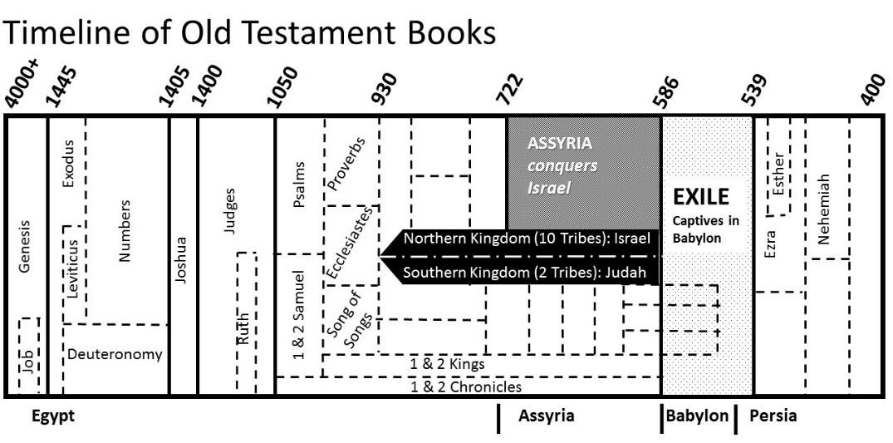

About Isaiah
- Isaiah’s focus: the salvation that will come through ____________

- Isaiah is the first of ________ prophetic books

- Chapters 1-12: restoration through __________________
Chapters 13-23: List the nations to be punished
Chapters 24-27: Announcing God’s new work in history
Chapters 28-39: Military might would not be God’s way
Chapters 40-55: Comfort to those who had ________________
Chapters 55-66: Renewed definition of God’s ________________

- The book of Isaiah is a miniature ________________
- ____________ chapters
- The first ________ correspond to the Old Testament
- The last ________ parallel the New Testament

- Isaiah receives his ____________ in Chapter 6:1-5

THE STORY
Peace and prosperity will come through the ____________________ Isaiah 9:2, 6-7…

- He calls us out of a spiritual death to life (Ephesians 2:4-6)

- He calls us out of a spiritual _________________________________

- He calls us to second chances after failure (John 21:15-17)

The “anointed one” (Messiah) will come

- Cyrus, king of Persia…

- Isaiah 53 – the “Suffering Servant”

Our Story (Isaiah 55:6-11)
1. _______________ God’s Word – it stands secure

2. Stand ______________ and when necessary stand _______________

3. Be the _______________ in the wilderness

