Ezra, Nehemiah and Esther
Series: The Story I Ezra, Nehemiah, Esther, ESV I February 28, 2016

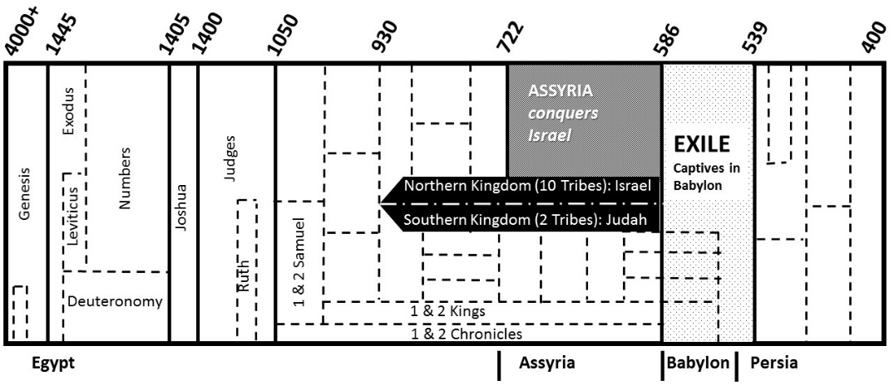
The books
EZRA
- 538 BC (1-6): 1st wave of Jews return
  - ________________________ altar and temple
  - ________________________ in God

- 458 BC (7-10): 2nd wave returns – led by Ezra (Priest)
  - Ch. 9-10: People ______________ and ________________

NEHEMIAH
- 445 BC: Nehemiah returns (Governor)
- _____________________: rebuilds the walls in _______ days
  - Ch 8. Ezra reads the __________________
  - Ch 9. People _________________ and _________________

ESTHER
- 486 BC – King of Persia: Ahasuerus (Xerxes 1)
- Haman’s plot to kill all the Jews
  - Esther’s boldness (Esther 4:15-16)
  - Haman ___________________ on his own gallows
  - God’s name…

The Story …
- EZRA and NEHEMIAH
  - We are called out of ____________ to be with Him
Rev. 18:2, 4, “Fallen, fallen is Babylon the great! … Come out of her, my people, lest you take part in her sins, lest you share in her plagues”

  - We are ______________ and ________________ in Him
Col. 2:6-7, “As you received Christ Jesus the Lord, so walk in Him, rooted and built up in Him and established in the faith”

  - We are ______________________ in Him
Col. 2:8-10, “See to it that no one takes you captive by philosophy and empty deceit, according to human tradition, according to the elemental spirits of the world, and not according to Christ. For in Him the whole fullness of deity dwells bodily, and you have been filled in Him, who is the head of all rule and authority”

- ESTHER
  - God is working in ways we do not see
  - The enemy is ________________ in his own plan
  - Colossians 2:13-15 (NLT), “You were dead because of your sins and because your sinful nature was not yet cut away. Then God made you alive with Christ, for He forgave all our sins. …He took it away by nailing it to the cross. In this way, He disarmed the spiritual rulers and authorities. He shamed them publicly by His victory over them on the cross.”

Our Story …

How do we come home out of captivity?

- _____________________ your sins

- Place your faith in ____________________

Ezra, Nehemiah and Esther
Series: The Story I Ezra, Nehemiah, Esther, ESV I February 28, 2016

The books
EZRA
- 538 BC (1-6): 1st wave of Jews return
  - ________________________ altar and temple
  - ________________________ in God

- 458 BC (7-10): 2nd wave returns – led by Ezra (Priest)
  - Ch. 9-10: People ______________ and ________________

NEHEMIAH
- 445 BC: Nehemiah returns (Governor)
- _____________________: rebuilds the walls in _______ days
  - Ch 8. Ezra reads the __________________
  - Ch 9. People _________________ and _________________

ESTHER
- 486 BC – King of Persia: Ahasuerus (Xerxes 1)
- Haman’s plot to kill all the Jews
  - Esther’s boldness (Esther 4:15-16)
  - Haman ___________________ on his own gallows
  - God’s name…

The Story …
- EZRA and NEHEMIAH
  - We are called out of ____________ to be with Him
Rev. 18:2, 4, “Fallen, fallen is Babylon the great! … Come out of her, my people, lest you take part in her sins, lest you share in her plagues”

  - We are ______________ and ________________ in Him
Col. 2:6-7, “As you received Christ Jesus the Lord, so walk in Him, rooted and built up in Him and established in the faith”

  - We are ______________________ in Him
Col. 2:8-10, “See to it that no one takes you captive by philosophy and empty deceit, according to human tradition, according to the elemental spirits of the world, and not according to Christ. For in Him the whole fullness of deity dwells bodily, and you have been filled in Him, who is the head of all rule and authority”

- ESTHER
  - God is working in ways we do not see
  - The enemy is ________________ in his own plan
  - Colossians 2:13-15 (NLT), “You were dead because of your sins and because your sinful nature was not yet cut away. Then God made you alive with Christ, for He forgave all our sins. …He took it away by nailing it to the cross. In this way, He disarmed the spiritual rulers and authorities. He shamed them publicly by His victory over them on the cross.”

Our Story …

How do we come home out of captivity?

- _____________________ your sins

- Place your faith in ____________________

