Job
Series: The Story I Job, ESV I March 06, 2016
- Job’s friends: You’re guilty!
- Job: I’m not guilty! (Job 32:1)
- The man born blind
John 9:2, “Who sinned…?”

3 categories of books in the Old Testament:
1) __________________ 2) _________________ 3) ___________________
Genesis – Esther Job – Song of Solomon
3 types of Hebrew _______________: lyric, instructional, dramatic

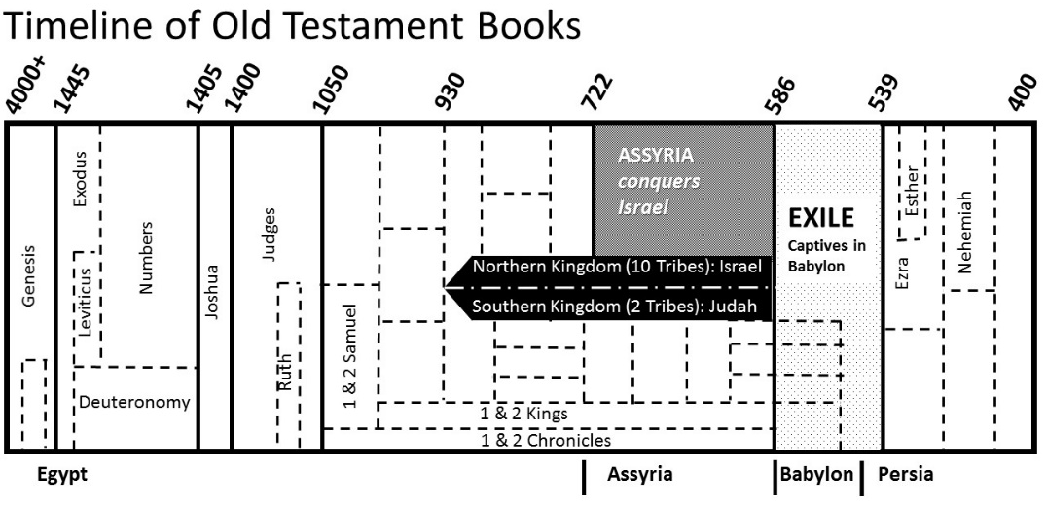
- Job’s wife (Job 2:9)
Overview of Job
- 1: Job is a righteous man
- 1-2: God allows Satan to test Job: loss of health, wealth and family
- 3-31: Job’s friends (Eliphaz, Bildad and Zophar) “comfort” him
- 32-37: Elihu (his name means “____________________”)
- 38-41: The Lord speaks to Job
- 42: Job repents and God restores his fortunes (plus more)

Job’s life
+ ++
^{Job 1: 3} ^{Job 42:12}

- - -
^{Job 10:1}

Our View of Suffering:
____________________________ - OR - ___________________________
- Elihu (Job 33:29-30)
- John. 9:3, “It was not that this man sinned… but that the works of God might be displayed in him.”

Our Focus in Suffering:
____________________________ - OR - ___________________________
We look to __________________ We look to __________________
- Connection with the _____________________ of Christ
  - Job 16:11-19…
  - 1 Peter 4:13…
- The _________________ of Christ
  - 1 Peter 4:1…
  - Phil. 3:7-9…

Our Outcome of Suffering:
____________________________ - OR - ___________________________
They don’t listen (Job 36:8-13) They listen (Job 42:3-6 (John 9:39))
- There is a ___________ (Job 23:10)
  - James 1:2-4…
- There is a ___________ (Job 13:15)
  - Job 19:25…
  - Hebrews 12:2-3…

Our Response to the Suffering (1 Peter 3:18)
____________________________ - AND - ___________________________
John 9:38; Job 9:33 Job 1:20-21

Job
Series: The Story I Job, ESV I March 06, 2016
- Job’s friends: You’re guilty!
- Job: I’m not guilty! (Job 32:1)
- The man born blind
John 9:2, “Who sinned…?”

3 categories of books in the Old Testament:
1) __________________ 2) _________________ 3) ___________________
Genesis – Esther Job – Song of Solomon
3 types of Hebrew _______________: lyric, instructional, dramatic

- Job’s wife (Job 2:9)
Overview of Job
- 1: Job is a righteous man
- 1-2: God allows Satan to test Job: loss of health, wealth and family
- 3-31: Job’s friends (Eliphaz, Bildad and Zophar) “comfort” him
- 32-37: Elihu (his name means “____________________”)
- 38-41: The Lord speaks to Job
- 42: Job repents and God restores his fortunes (plus more)

Job’s life
+ ++
^{Job 1: 3} ^{Job 42:12}

- - -
^{Job 10:1}

Our View of Suffering:
____________________________ - OR - ___________________________
- Elihu (Job 33:29-30)
- John. 9:3, “It was not that this man sinned… but that the works of God might be displayed in him.”

Our Focus in Suffering:
____________________________ - OR - ___________________________
We look to __________________ We look to __________________
- Connection with the _____________________ of Christ
  - Job 16:11-19…
  - 1 Peter 4:13…
- The _________________ of Christ
  - 1 Peter 4:1…
  - Phil. 3:7-9…

Our Outcome of Suffering:
____________________________ - OR - ___________________________
They don’t listen (Job 36:8-13) They listen (Job 42:3-6 (John 9:39))
- There is a ___________ (Job 23:10)
  - James 1:2-4…
- There is a ___________ (Job 13:15)
  - Job 19:25…
  - Hebrews 12:2-3…

Our Response to the Suffering (1 Peter 3:18)
____________________________ - AND - ___________________________
John 9:38; Job 9:33 Job 1:20-21

